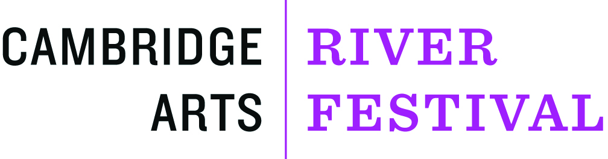
SATURDAY, JUNE 1, 2019

CALL FOR VOLUNTEERS!

WHAT: Cambridge Arts River Festival; Celebrate the arts with this FREE festival along the banks of the Charles River, featuring:
    - Hundreds of local & nationally renowned jazz, folk, roots, and world music performers on multiple stages.
    - Family entertainment & art-making activities
    - Over 100 specialty food purveyors and craftspeople
    - Public art installations designed for the festival

WHEN: Saturday, June 1, 2019 11-6pm

WHERE: Along Massachusetts Avenue, between Prospect and Sidney Street, and down Sidney Street to Pacific Street.

ATTENDANCE: ~175,000 annually
ADMISSION: Event is FREE and Open to ALL!
INFORMATION: www.cambridgeartscouncil.org/riverfestival or 617-349-4380

VOLUNTEER INFORMATION:
We need volunteers to help with various activities throughout the festival. The breakdown of shifts is:

8am-12pm – This will include setting up for the day, such as hanging signs, delivering festival materials to the various stages, assisting vendors with questions, setting up pop-up tents, etc.

11:30am-4pm – During this time the festival will be in full swing. Volunteers may be stationed at one of the many entertainment stages as merch vendors, assisting with interactive areas and children’s activities, running supplies and materials between venues etc.

3:30pm-8pm – This shift will include assignments from the 11:30-4 shift but will also include clean up and breakdown of the festival. The festival ends at 6pm sharp and we all do our part to gather the stage signs and materials, bring them back to one central location, fold up tents and tables, and assist in clean up of the festival grounds.

Volunteers are requested to arrive 15 mins before their shift begins. Volunteer check-in is at the Main Information Tent, which will be located adjacent to the Asgard Irish Pub, at the intersection of Mass Ave and Sidney Street. Parking will be limited and therefore taking public transportation is highly recommended. The nearest T stations are Kendall/MIT and Central Square both on the Red Line.

All volunteers are given a food voucher that can be used at any of the delicious vendors. No matter what shift you worked you are more than welcome to join us for a BIG THANK YOU at the end of the day, we hope to see you there!!

If you are interested in volunteering or if you have already signed up to volunteer and have questions before the big day, please contact Arielle Goldhaber or Taylor Mortell at crf_volunteers@cambridgema.gov

